**Student Questions**

Learn about the internals of a standard PC case by examining physical samples and selecting and labeling images found on-line. Gain deeper knowledge by researching and reporting on specific components.

PC Tower Case

1. Find one (or more) images that clearly show the internals of a PC Tower Case.   
   (i.e. Google images using keywords “PC Case Internals”)

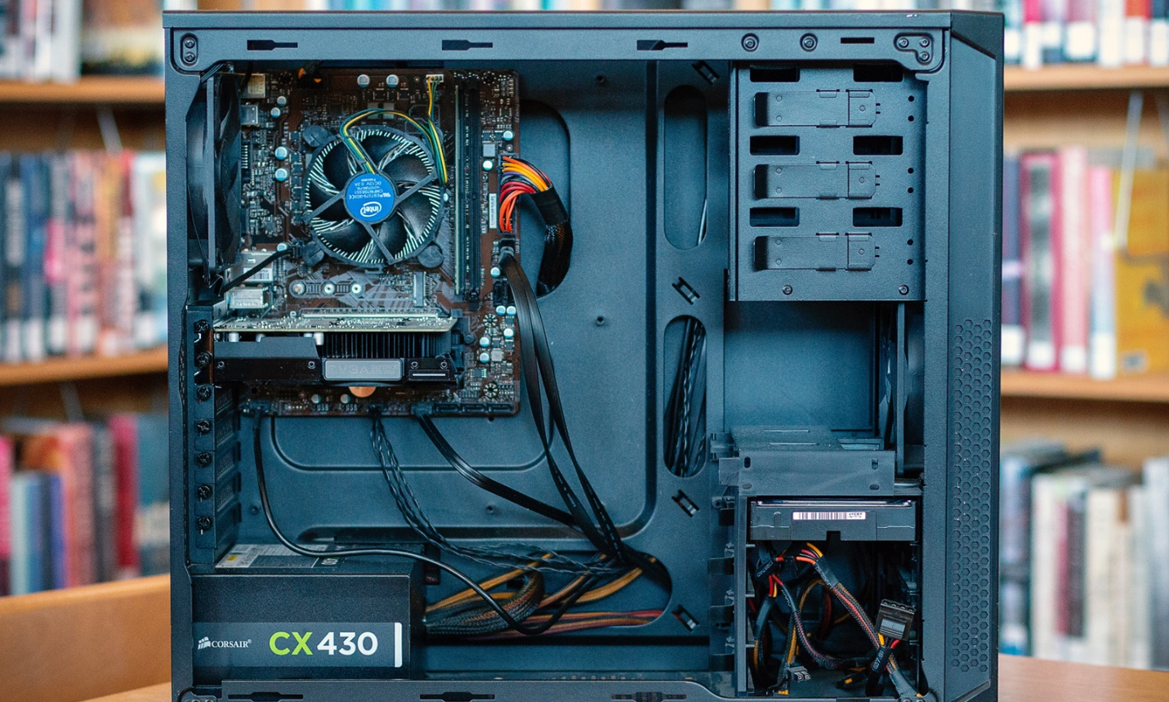

1. Clearly label the following components (using arrows) on your image of the PC case internals:
   1. Motherboard
   2. Power Supply
   3. Hard Disk Drive
   4. Optical Disk Drive (e.g.DVD)
   5. USB Expansion Ports
   6. Monitor Port
   7. Audio Ports
   8. Ethernet Port
   9. Cooling Fan
2. Research more in-depth about “Hard Disk Drives”. Make notes on the following:
   1. What different versions are currently available (speed and capacity)

There are many capacities of hard drives; 100gb, 500gb, 1-4tbs. There is 5400RPM drives and 7200RPM drives (which is the standard disk speed).

* 1. How the capacity of the component has changed since the 1980’s  
     There are many capacities of hard drives; 100gb, 500gb, 1-4tbs. There is 5400RPM drives and 7200RPM drives (which is the standard disk speed).
  2. PC Motherboard

1. Find one (or more) images that clearly show the layout of a PC Motherboard.   
   (i.e. Google images using keywords “PC Motherboard”)

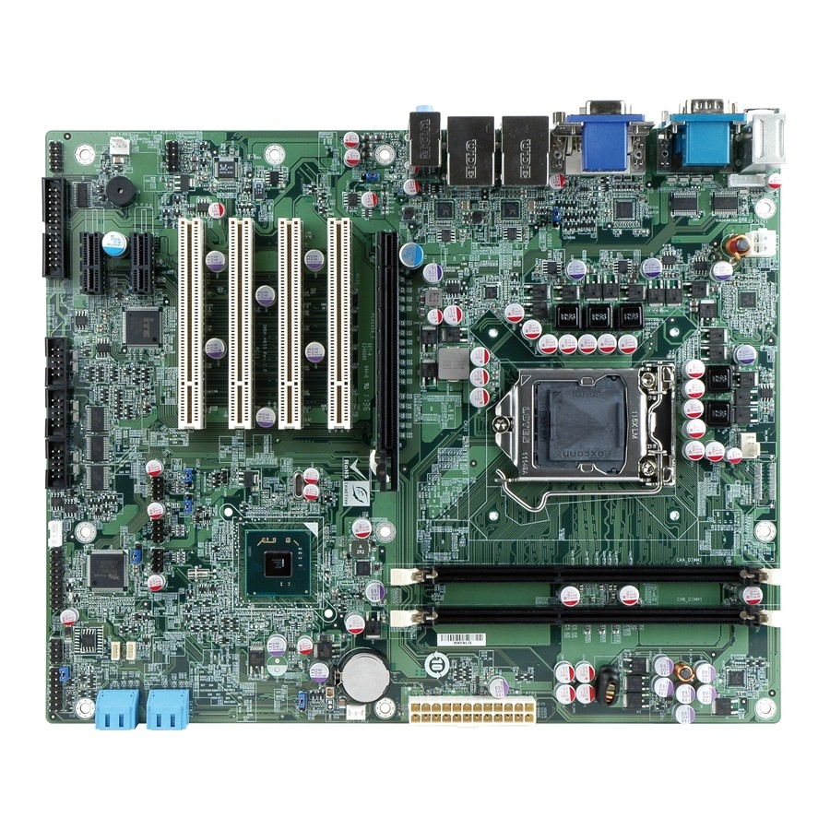

1. Clearly label the following components (using arrows) on your image of the PC motherboard:
   1. CPU (and fan)
   2. RAM Memory
   3. Disk Drive Interface (IDE or SATA)
   4. GPU Graphics Processor (either on-board or Graphics Card)
   5. Sound Processor (either on-board or Sound Card)
   6. Wi-Fi / Ethernet Network Interface (either on-board or Graphics Card)

1. Research more in-depth about “CPU Processor Chip”. Make notes on the following:
2. What different versions are currently available (speed and capacity)

There are many capacities of hard drives; 100gb, 500gb, 1-4tbs. There is 5400RPM drives and 7200RPM drives (which is the standard disk speed).

1. How the speed of the component has changed since the 1980’s  
   There are many capacities of hard drives; 100gb, 500gb, 1-4tbs. There is 5400RPM drives and 7200RPM drives (which is the standard disk speed).

Peripheral Devices

1. Find one (or more) images that clearly show the layout of the back of a typical PC tower case.   
   (i.e. Google images using keywords “Back Of PC Tower”)

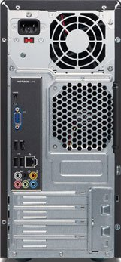

1. Clearly label the following components (using arrows) on your image of the back of a typical PC tower case:
   1. Power cord and power switch
   2. Monitor Interface (VGA or DVI or HDMI)
   3. Mouse Interface (USB or PS/2)
   4. Keyboard Interface (USB or PS/2)
   5. USB Ports
   6. Audio Inputs / Outputs
   7. Ethernet Interface

1. Research more in-depth about “External Portable Storage”. Make notes on the following:
2. Floppy Disks

Very outdated storage device. Holds low amounts

1. CD-ROM / DVD / Recordable CD/DVD

Somewhat outdated. Can hold 1gb-10gb of storage. Can be written and read by using an optical drive.

1. USB Memory Drives

Highly compact, fast and can hold high amounts of storage, like 256gb. Plugged into PC by USB ports.

1. Compact Flash Memory

Very fast storage, highly compact. Read and write speeds very efficient. Can be put into SD card reader in pc/laptop.

1. Cloud Based Storage

Stores files in a remote server room. Not natively stored on PC’s hard disk drive. Virtual storage. Ex. Google drive.